*Specification for handling supplier test documents*

Content

Purpose / target 2

Scope 2

Responsibilities 2

Content / Description 2

1. Digital archiving and recording of test documents 2

2. Files / Forms 2

3. Required documents 2

4. Individual parts and assemblies 2

5. Naming the files 3

6. Example Measurement Control Sheet (TCF0011/TP001145) 4

# Purpose / target

This work instruction specifies, how test documents are transmitted to Aixtron SE. Furthermore a sample is used to show, how to complete the measurement control sheet TCF0011.

# Scope

The regulations of this work instruction apply to all suppliers of Aixtron SE.

# Responsibilities

The department Product Quality (PQ) is responsible for this work instruction.

# Content / Description

## Digital archiving and recording of test documents

* All required test records by AIXTRON SE must be provided before delivery.
* The test records must be stored in the **common exchange drive** (**E**xternal**D**ata**E**xchange).
* The documents must be filed in the folder "Testdocuments". 
* This folder may only be used for test records.
* The test documents must be signed (also Digital).

## Files / Forms

* **No** packed files! (rar, zip, etc.)
* Measurement data for evaluations and recording are to be transmitted in Excel format.
* All other test certificates shall be submitted in PDF format.

## Required documents

Inspection documents are only to be submitted if requested by Aixtron SE.

The request will be made either directly through the drawing (CS0008 & CS0117) or specifically through the Aixtron Purchase Order.

## Individual parts and assemblies

* If a single part is ordered, the corresponding measurement control sheet must be recorded individually.
* If an assembly is ordered, **all** corresponding measurement control sheets must be combined to **one** PDF-file.
* An assembly must be identified only by one identification number following the SAP material number (CS0024).

**Attention please! The SAP-material number is not identical with the drawing number!**

## Naming the files

* The file name is a combination of the SAP- order number, the SAP-material number and the ID number of the material.
* For materials that do not require an ID number, the term is reduced to the SAP-order number and the SAP-material number

**Examples for the designation of files**

|  |  |  |  |  |  |  |  |  |  |
| --- | --- | --- | --- | --- | --- | --- | --- | --- | --- |
| 45000……-100075313 | | | | | | | | | |
| 45000……-100075313-100057616011-4 |  |  | | | | | | | |
| 45000……-100075313-100057616011-8 to 22 (only for linked ID numbers!) |  |  |  |  |  |  |  |  |  |
|  | | | |  |  |  |  |  |  |
| **SAP- order number- SAP-material number -**ID number | | | | | | | | |  |

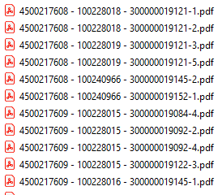

## Example Measurement Control Sheet (TCF0011/TP001145)

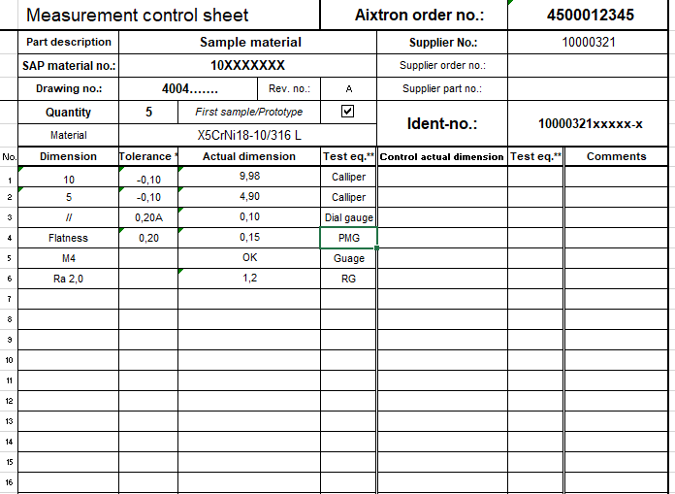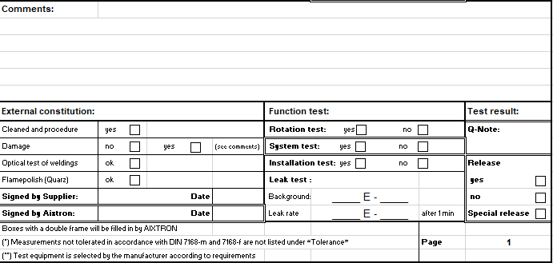

Assembly tests or He-leakage tests that have been carried out, are documented here.

Applicable fields must be marked with a cross. The acceptance date must be entered. The protocol must be signed (digital is permitted!).

Designation of the test equipment

Document engraved ID no. or adopt existing ID no.

The Aixtron order number must be entered with ten digits. The supplier number (vendor) is specified in the order.

First samples are specified in the Aixtron purchase order

Quantity of measured parts

CS0008: If there are several parts of a material, the smallest to largest dimension of all parts can be entered here.

CS0117: According to the company standard, the value of each individual part of a material must be entered here.

The drawing number is shown in the Aixtron purchase order

The SAP material no. has nine digits einzugeben

**Sample**